ECE170B Project 1

Start date: **January 23, 2020**

Due Date: **February 6, 2020 by 5pm**

Assignments:

**-------------------------------------------------------------------------------------------**

**Instructions:** You will use Matlab for this project. **It is required that you use the Livescript tool and type your answers as text and equations in Livescript and turn in the .mlx file as your homework.**

**Submission**: You will submit your file(s) online using CCLE. There will be an assignment sub-folder with the Project Name (e.g. Project 1)

Problem 1: Consider an optical resonator with mirror separation of 250 μm and the mirror reflectivity are 99%. Assume refractive index n=1.45. For the mode at 1500 nm, perform the following analysis in Matlab:

(a) plot the phase shift, after propagation in the cavity, from 1500 nm to 1520 nm as a function of wavelength. Repeat the plot but this time as a function of frequency. (make 2 separate plots)

(b) Calculate the cavity Finesse

(c) Calculate Free-spectral range

(d) Calculate spectral width

(e) Calculate the mode number at 1550nm

(f) Calculate the Q factor for the mode at 1550nm

(g) plot the Intensity spectrum of Fabry-Perot resonator vs. wavelength and vs. frequency over the same wavelength range.

(h) Plot the inverse Fourier transform of the spectrum calculated in the previous part to obtain the temporal response. We know that the spectrum can be explained by interference of reflected waves in the cavity. How do you explain the temporal response?

(i) Calculate the photon lifetime.

(j) Calculate the ratio of photon lifetime to cavity roundtrip. How do you explain your answer in terms of cavity parameters?

**Problem 2: Dispersive Resonator**

Problem 2: Effect of dispersion on the resonator: For the same resonator, consider the internal medium to have group velocity dispersion (also called group delay dispersion) with the following dispersion parameters:

reference wavelength is 1510 nm (center of 1500-1520nm range)

beta_1 = You can calculate this

beta_2 = -2E-26 sec^2/m (this is for standard single mode fiber (SMF)) beta_3 = 1E-40 sec^3 (for standard single mode fiber (SMF))

**Definitions of dispersion parameters:**

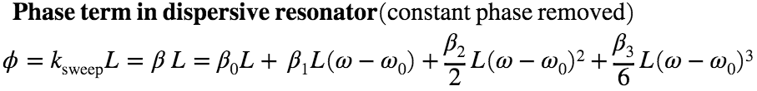

**Definitions of dispersion parameters:**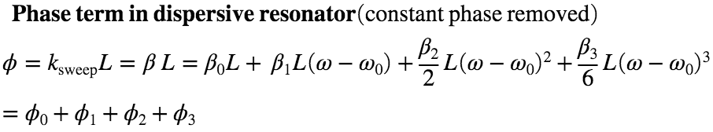

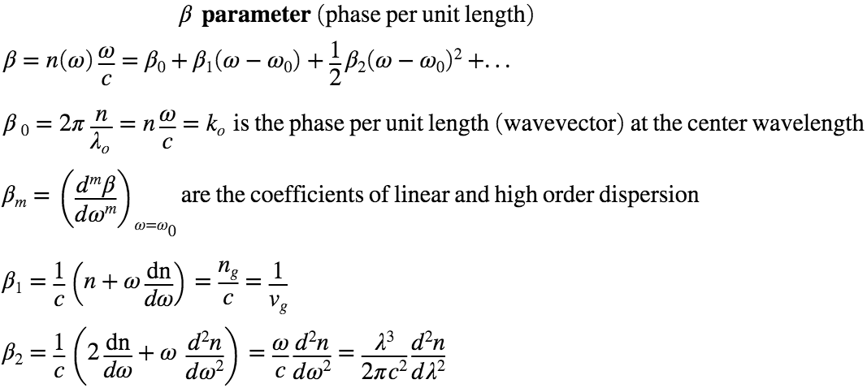

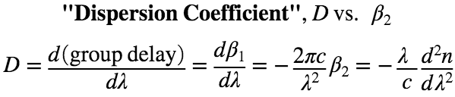

a) plot the phase shift, after propagation in the cavity, from 1500 nm to 1520 nm as a function of wavelength. Repeat the plot but this time as a function of frequency. (make 2 separate plots)

(b) Plot the group delay vs. wavelength and vs frequency over the same range.

(c) calculate the value of the four terms in the Taylor expansion of the phase. For the frequency dependent terms, obtain the maximum value, i.e. at the edge of the frequency range corresponding to 1500-1520nm wavelength.

(c) plot the Intensity spectrum of Fabry-Perot resonator vs. wavelength and vs. frequency over the same wavelength range.

(d) Plot the inverse Fourier transform of the spectrum calculated in the previous part to obtain the temporal response. We know that the spectrum can be explained by interference of reflected waves in the cavity. How do you explain the temporal response?

(e) Increase beta_2 by 1E5. Plot the resonator spectrum vs. wavelength and vs. frequency over the same wavelength range. Explain your results.

(f) Reset beta_2 to the original value and increase beta_3 by 1E7. Plot the resonator spectrum vs. wavelength and vs. frequency over the same wavelength range. Explain your results.

**Helpful Resources**

**Dispersion:**

1. Class notes
2. <https://en.wikipedia.org/wiki/Group_velocity>
3. <https://en.wikipedia.org/wiki/Group_velocity_dispersion>
4. <https://paginas.fe.up.pt/~hsalgado/co/docs/phase_group_vel_dispersion.pdf> (has the derivation of dispersion penalty)
5. **Access to Matlab**
6. You will be using MATLAB in this class and need a SEASNET account.
7. <https://softwarecentral.ucla.edu/matlab-getmatlab>
8. **Matlab Resources**
9. See the Syllabus, also for Fourier Transform, see:
10. <https://www.mathworks.com/help/matlab/math/fft-for-spectral-analysis.html>
11. <https://www.mathworks.com/help/matlab/math/fourier-transforms.html>